Create parameter

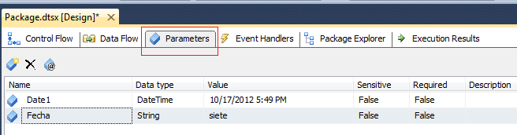

Create variable

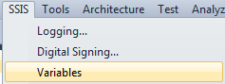

Assign the variable “HOY” GETDATE()

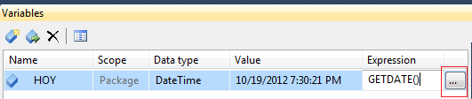

**PASSING PARAMETERS TO SQL TASK**

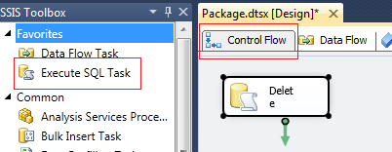

Configure SQL Task

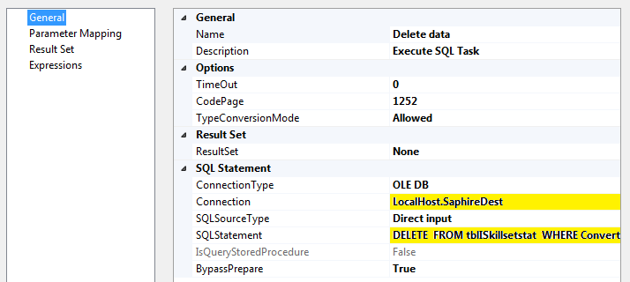

DELETE FROM tblISkillsetstat WHERE Convert(Varchar(8), TimeStamp, 112)= ?

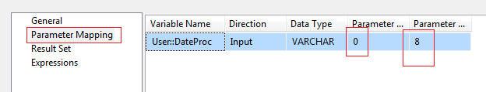

Parameter 0, 1, 2 ,3

**RETURN COUNT OF ROWS**

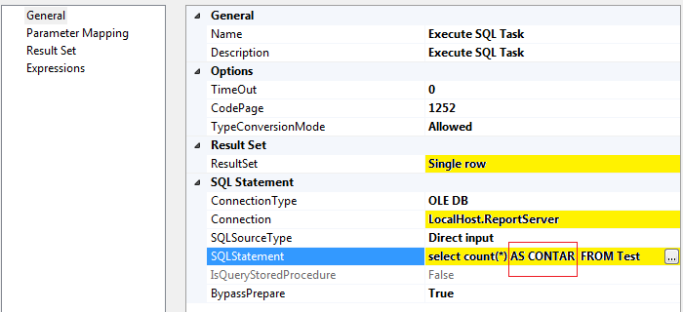

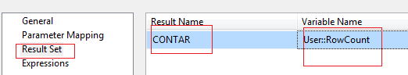

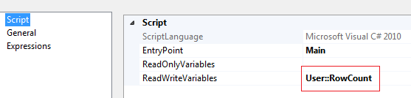

public void Main()

{

MessageBox.Show(Dts.Variables["RowCount"].Value.ToString());

Dts.TaskResult = (int)ScriptResults.Success;

}

The question mark ? indicates that we need a parameter for this query.

Attention: when writing SQL query in this editor, always start with a simple query. The editor is not very sophisticated SQL editor. Complex SQL queries will confuse the editor.

[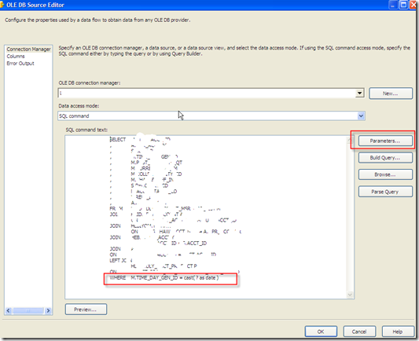](http://bisherryli.files.wordpress.com/2011/03/image10.png)

**Step 5: Click the Parameters… button.**

In the Set Query Parameters windows, add a parameter by setting Parameter0 under Parameters, and User::vLoopDate under Variables.

Continue to finish the Column mappings.

[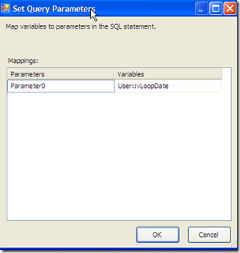](http://bisherryli.files.wordpress.com/2011/03/image11.png)

We are done now.

SELECT ID, nombre

FROM Test

WHERE (ID = @Param1)

1. Select your data flow task and in the properties window, click the ellipsis next to Expressions.

2. In the Property Expression Editor and in the Property drop down list, select [ADO NET Source].[SqlCommand].

3. Click the ellipsis under Expression and build your SQL Command in there. It should look something like this:

"Select Title from Person.Contact Where Title = '" + @[User::Title] + "'"

I hope this helps. Let me know if you have any other questions.

1)   Switch to **Control Flow**, click the **Data Flow Task**.

2)   In the **Properties** window, notice a property called **Expression** and a small button next to it. Click the button to open the Expression Editor.

3)   In the Property list, select **[The name of ADO NET Source].[SqlComamnd]** and click the button under expression column to open **Expression Builder**.

4)   Write the query with variable names and click the **Evaluate Expression** button to test the expression. For example:  
"SELECT * FROM EMPLOYEES WHERE FNAME='" + @[User::FName] + "'